**Day 1  
Project Title : *Gym Trainer & Progress Tracking App***

**Class Diagram  
  
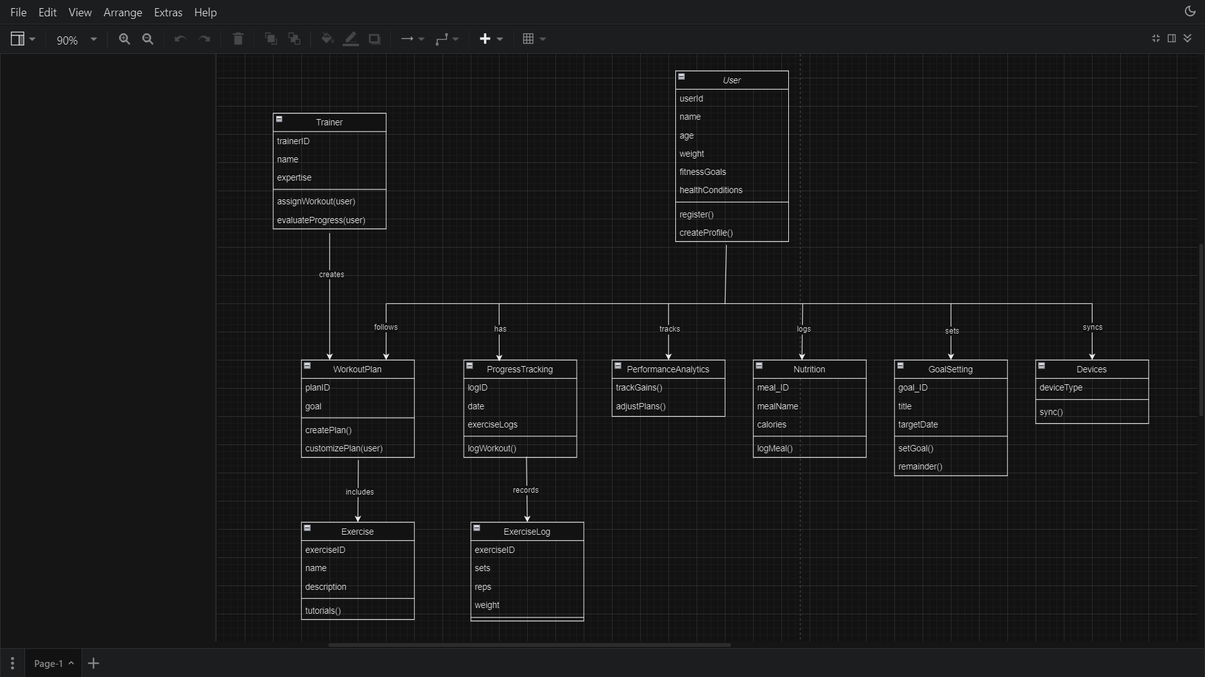  
  
  
  
  
ER Diagram  
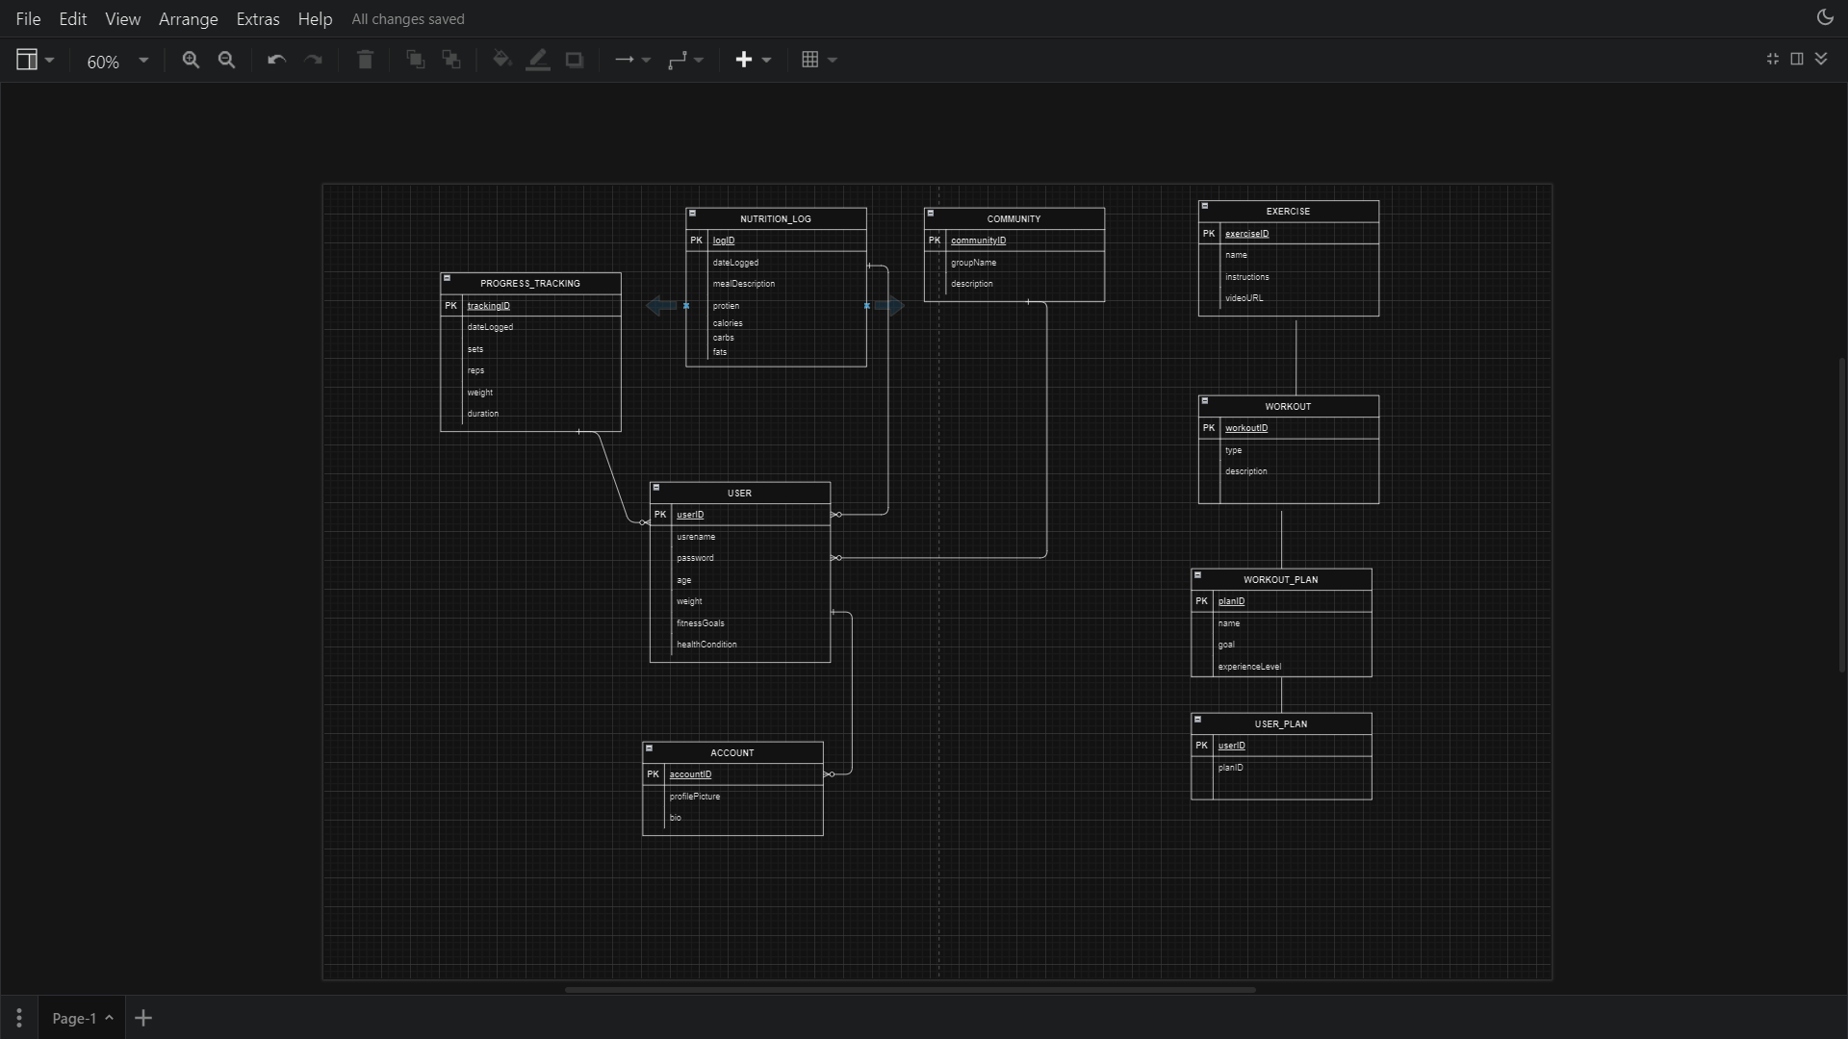  
  
  
Sequence Diagram  
  
